**Computational Lab 1:**

**Simulations of Two Nonlinear Fibers in Series**

**Matthew Mirek**

**Due: 9/30/2016**

**Extracellular Matrix: BE549**

**Professor Suki**

**Introduction & Theory:**

In tissue, springs usually are modeled as nonlinear to be characterized correctly. In this lab a simplified model of two nonlinear spring series will be used as shown in *Figure 1.* By developing a Matlab code to calculate the displacement, energy, force, and stress strain curve the behavior of the spring system can be analyzed, and an intuitive sense of how springs in series behave can be achieved.

Figure 1: Two springs in series

For this lab, the energy of each spring can be determine from *Equation 1*, where the variable is the displacement of the individual spring. The Matlab code uses this equation to see where the minimum total energy is, by varying the contribution that each spring adds to the total displacement. In order to calculate the total displacement.

$E_{i}=\frac{1}{2}a_{i}x_{i}^{2}+\frac{1}{3}b_{i}x_{i}^{3}+\frac{1}{4}c_{i}x_{i}^{4}$ (i=1,2)

Equation 1: Energy of Non-linear Spring

**Matlab Code Setup:**

Instead of creating individual functions, a series spring class was created. By using classes in Matlab, an object can be created that has all of the properties and variables of two springs, as well as the stretched length. Then by referencing the object in Matlab, integrated functions can be called to display Xp, Force, Energy, and the Stress-Strain Curve. In *Figure 2*, an example of how a spring system can be initialized is shown. *Figure 3* shows how the series spring class can be used. The class code is attached the appendix of this lab.

A1

B1

C1

Len1

A2

B2

C2

Len2

Total Length



Figure 2: Initialization of the Series Spring Class

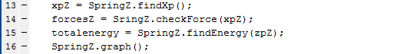 

Figure 3: Utilization of Series Spring Class

**Questions:**

**1)** *Figure 4*, shows that midpoint between two equal and linear screen is 2, when the total length is 4. Xp1 shows the correct answer is 2.0000.





Figure 4: Linear System Initial Calculation and Result

**2)** To further verify the Matlab code, two linear springs will be tested where a1=1 and a2=2. In the appendix this calculation is determined analytically as well, where Xp = 2.3333. The forces are also checked by comparing if both springs exhibit a force that are equal to each other, where they only differ by .0001. *Figure 5*, displays the Matlab code used, the calculated Xp, and the forces of the two springs. The analytical and numerical solution show Xp = 2.3333.







Figure 5: Linear System with non-identical springs

The next verification step is to calculate Xp and forces for a nonlinear system. The values that will be used are: a1=a2=1, b1=b2=0.1 and c1=c2= {1, 10, 100}. *Figure 6,* shows that even with the increasing Ci value, F1 = F2 with a high level of prevision. Since the xp is 2.000 for all and the springs are equal, that further verifies the accuracy of the solver.

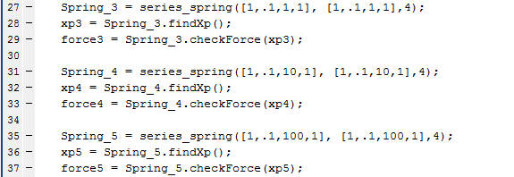

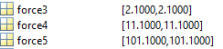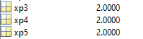

Figure 6: Nonlinear Spring with Varying Ci

**3)** For this section, the left spring will be set to be linear, while the right spring will be set to be linear. For both springs a1=a2=1, b1=b2=0, but for c1=0, and c2={1,5,10,100}. Both the stress-strain curve, and force-displacement curve will be plotted for each spring system. The additional function of the force-displacement curve was added since it demonstrates that the microdisplacements of each spring add up to the total displacement of the spring system.

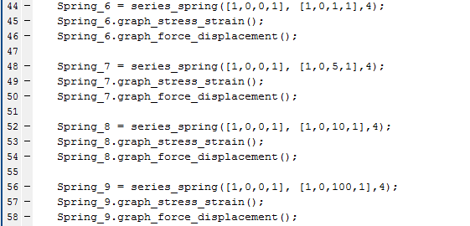

Figure 7: Input used for Nonlinear Springs for Question 3

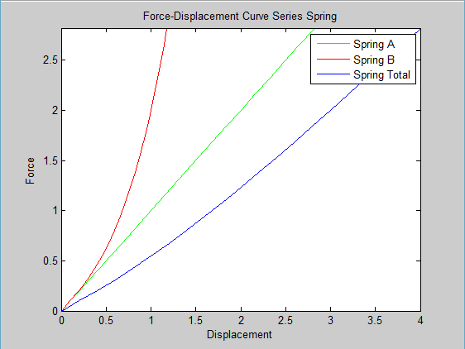 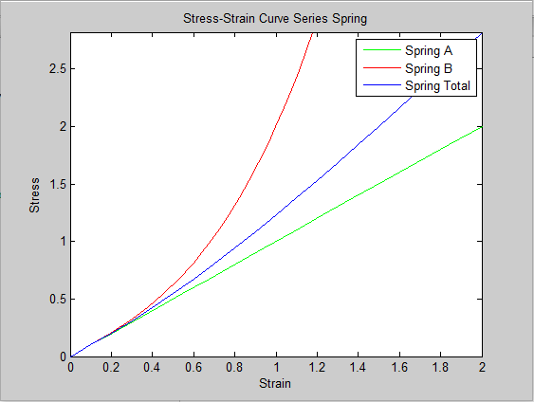

Figure 8: C2 = 1 Spring System

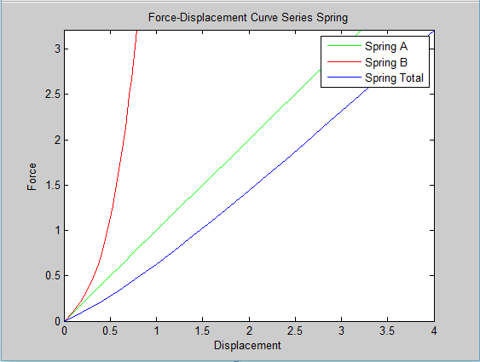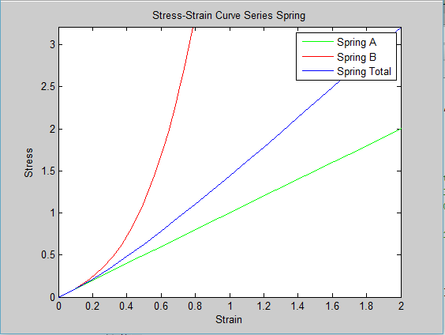

Figure 9: C2 = 5 Spring System

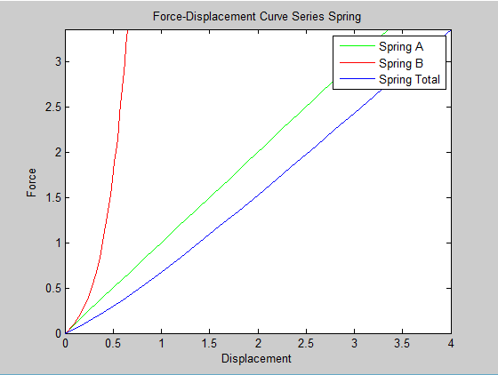 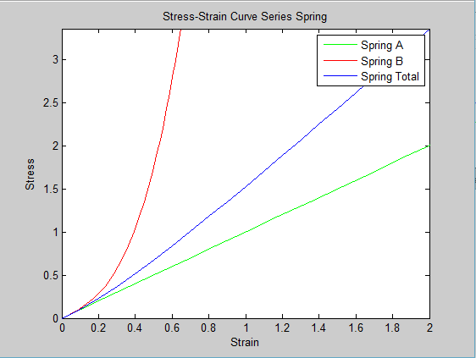

Figure 10: C2 = 10 Spring System

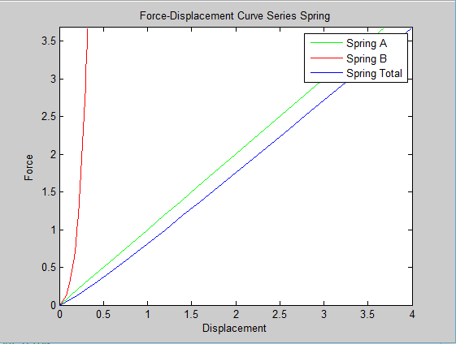 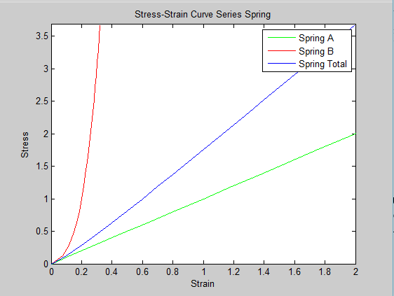

Figure 11: C2 = 100 Spring System

**4)** In this problem, the purpose is to generate a highly nonlinear curve showing a knee. This means that the system in the initial displacement should have a low modulus in the stress strain curve, while in later displacement there should be a high modulus on the stress strain curve. *Figure 11* shows the inputs for the spring system, while *Figure 12* shows the stress strain curve for the system.



Figure 12: Inputs for Knee Spring System

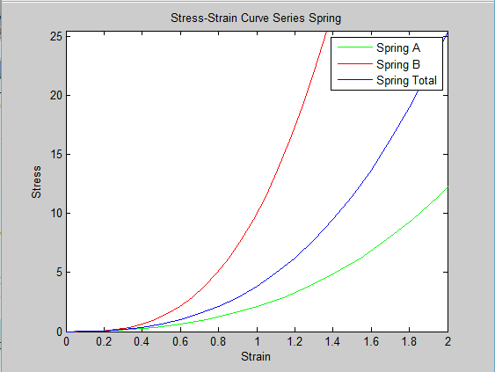

Figure 13: Stress - Strain Curve for Knee System

**5)**

**-1-** The “knee’ is generated by having an extremely nonlinear spring system. By look at *Figure 13*, it can be seen that the spring system starts off with a low modulus that slowly begins up in to a higher modulus region. Mathematically this makes sense with the nonlinear system used since the terms **b** and **c** have displacements that are cubed and quadrupled, respectively. With small ∆x, these terms do not contribute a lot to the energy of the system. However in larger ∆x the later terms with higher exponents end up contributing more to the modulus of the system. This explains why in *Figure 13*, there is a close exponential resemblance once you get past a strain of a 100% since the spring is becoming stiffer.

**-2-** In terms of modeling for recruitment, this model would be able to represent a stress strain curve that is incurring recruitment. By changing the values of the two nonlinear springs and use of minimization of R2 between the best fit line and data points, an accurate model could be achieved. However the model of using two springs in series is inherently flawed. Recruitment is best modeled by springs in parallel, where the initial load is placed on one springs, and then as greater displacement is achieved, more springs contribute energy to the overall system. In this model, a lower modulus with small displacements since one spring is contributing to the system, and a higher modulus once more springs are incorporated. A parallel model will include a more accurate physiological representation of the contributing factors to recruitment.

**-3-** By look at the displacement versus force graphs in question 4, it can be seen that both the nonlinear and linear spring contribute to the overall displacement of force. However with increasing displacement, the nonlinear spring becomes stiffer and encumbers less displacement to the overall system with increases strain. Therefore the linear spring becomes the sole contributor to the overall displacement with large ∆x.

**6)** Results from the stress strain curves achieved in question 4 can be used to come up with a cohesive experimental design. It can be noted that after the nonlinear spring becomes stiffer with increasing displacement it contributes less to the overall displacement of the system. Since the linear spring is contributing to the system at that point, a strong experimental design would be using something similar AFM (Atomic-Force Microscopy) to pull on a buddle of collagen fibers and recreate a force-displacement curve from the response. In terms of requirements, the fibers would have to be pulled until a linear relationship is achieved between the force and displacement. As observed in question four, with larger displacements, the slope of the curve of the total system, is identical to the linear spring. Therefore, these results can be extrapolated to figure out the k-constant for the linear spring, leaving only the variables characterized by the nonlinear unsolved. However the stress strain curve can be used to solve for the variables of the nonlinear spring through curve fitting and minimizing R^2. It also should be noted that when the nonlinear terms are small compared to the coefficient for the linear springs, initial displacements can be used to characterize the nonlinear spring, which can be seen *Figure 15.* Therefore from analysis of the force displacement curve of the elastin – collagen system, would provide enough information to understand the microscopic properties of the elastin and collagen individually.

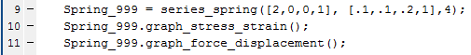

Figure 14: Values for Spring System for a1 >> c2

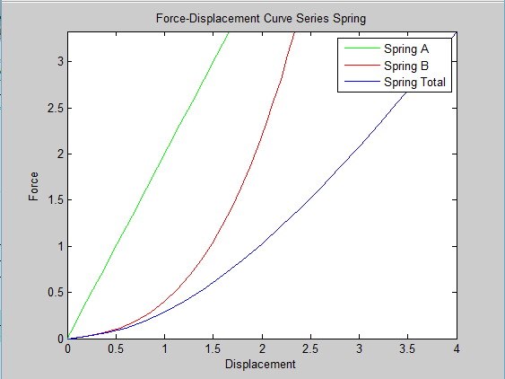

Figure 15: Force Displacement Curve for Spring System where a1 >> c2

**Extra Credit:**

The extra credit was to solve for Xp analytically assuming ci = 0 (i = 1,2) and then compare the solution with the Matlab model. Attached to the appendix are the analytical calculation that were used to determine the midpoint of the spring. In *Table 1*, the values used in the calculation are listed. In *Figure 1*, the Matlab script that was used to execute the calculation is displayed. For both the analytical and graphical solution, Xp equated to 1.9654.

|  |  |  |
| --- | --- | --- |
|  | Spring Left (1) | Spring Right (2) |
| ai | 2 | 3 |
| bi | 7 | 5 |
| ci | 0 | 0 |
| Rest Length | 1 | 1 |

Table 1: Values for Bonus Question





Figure 16: Matlab Calculation of Bonus Question

**Appendix:**

***Class series_spring***

%Computaional Lab 1

%Matthew Mirek

%Overview: This class initialized two nonlinear springs in series, and

%solves for the middle distance between the two springs by using minimum

%function solver. By initializes an instance of the object you can pull

%information about the spring and graph stress strain graphs of the

%function.

classdef series_spring

properties

%Spr_A and Spr_B ask for a 4 part array, where:

%[term ai, term bi, term ci, unstressed length]

Spr_A %Left Spring

Spr_B %Right Spring

Xe %Endpoint of two springs combined

Xo = 0;

end

methods

%Constructor class, initiliazes variables

function obj = series_spring(A, B, length)

if nargin > 0

obj.Spr_A = A;

obj.Spr_B = B;

obj.Xe = length;

end

end

%Calculates energy for a given midpoint for combined spring system.

function E = findEnergy(obj, Xp)

Disp_A = ((Xp - obj.Xo) - obj.Spr_A(4)); %Displacement

Disp_B = ((obj.Xe - Xp) - obj.Spr_B(4));

EnergyA = 1/2*obj.Spr_A(1)*power(Disp_A, 2)+ 1/3*obj.Spr_A(2)*power(Disp_A, 3) + 1/4*obj.Spr_A(3)*power(Disp_A, 4);

EnergyB = 1/2*obj.Spr_B(1)*power(Disp_B, 2)+ 1/3*obj.Spr_B(2)*power(Disp_B, 3) + 1/4*obj.Spr_B(3)*power(Disp_B, 4);

E = EnergyA + EnergyB;

end

%Utilizes findEnergy to find the location of the midpoint by

%minimizing the energy

function E = findXp(obj)

E = fminsearch(@obj.findEnergy,0);

end

%takes in midpoint, and calculates array

function E = checkForce(obj, Xp)

Disp_A = ((Xp - obj.Xo) - obj.Spr_A(4));

Disp_B = ((obj.Xe - Xp) - obj.Spr_B(4));

ForceA = obj.Spr_A(1)*power(Disp_A, 1)+ obj.Spr_A(2)*power(Disp_A, 2) + obj.Spr_A(3)*power(Disp_A, 3);

ForceB = obj.Spr_B(1)*power(Disp_B, 1)+ obj.Spr_B(2)*power(Disp_B, 2) + obj.Spr_B(3)*power(Disp_B, 3);

E = [ForceA ForceB] ;

end

%graphs stress strain for the system, and each individual spring

function graph_stress_strain(obj)

temp = obj.Xe;

results = [ 0, 0, 0, 0, 0, 0];

for x = 0.2:.2:.2*20

obj.Xe = obj.Spr_A(4) + obj.Spr_B(4) + x;

mid = obj.findXp();

force = obj.checkForce(mid);

A = [(mid - obj.Spr_A(4))/(obj.Spr_A(4)), force(1),(obj.Xe - mid - obj.Spr_B(4))/obj.Spr_B(4), force(2),x/(obj.Spr_A(4)+obj.Spr_B(4)), force(1)];

results = [results; A];

end

obj.Xe = temp;

figure(1)

plot(results(:,1),results(:,2), 'g' ,'DisplayName','Spring A')

hold on

plot(results(:,3),results(:,4), 'r' ,'DisplayName','Spring B')

hold on

plot(results(:,5),results(:,6), 'b' ,'DisplayName','Spring Total')

hold on

axis([0,2,0,max(results(:,6))])

xlabel('Strain')

ylabel('Stress')

title('Stress-Strain Curve Series Spring')

legend('show')

end

%graphs force displacement for the system, and each individual spring

function graph_force_displacement(obj)

temp = obj.Xe;

results = [ 0, 0, 0, 0, 0, 0];

for x = 0.2:.2:.2*20

obj.Xe = obj.Spr_A(4) + obj.Spr_B(4) + x;

mid = obj.findXp();

force = obj.checkForce(mid);

A = [(mid - obj.Spr_A(4)), force(1),(obj.Xe - mid - obj.Spr_B(4)), force(2),x , force(1)];

results = [results; A];

end

obj.Xe = temp;

figure(2)

plot(results(:,1),results(:,2), 'g' ,'DisplayName','Spring A')

hold on

plot(results(:,3),results(:,4), 'r' ,'DisplayName','Spring B')

hold on

plot(results(:,5),results(:,6), 'b' ,'DisplayName','Spring Total')

hold on

axis([0,.2*20,0,max(results(:,6))])

xlabel('Displacement')

ylabel('Force')

title('Force-Displacement Curve Series Spring')

legend('show')

end

end

end

***Implementation Matlab Code:***

%================Lab 1, 2 Nonlinear Fibers in Series======================%

%QUESTION 1

%First, stretch the system to a length L of 4, i.e. the right end is moved

%to x=4, provide an initial estimate for the mid position and let fminsearch

%find the position. Use a linear system first with a1=a2=1 and b=c=0. Check

%your solution that the midpoint is at xp=2.

Spring_1 = series_spring([1,0,0,1], [1,0,0,1],4);

xp1 = Spring_1.findXp();

%QUESTION 2

%To further check your system, compute analytically the midpoint for a

%linear system in which the 2 springs are not the same: a1=1 and a2=2.

Spring_2 = series_spring([1,0,0,1], [2,0,0,1],4);

xp2 = Spring_2.findXp();

force2 = Spring_2.checkForce(xp2);

%Now go back to the homogeneous system and make it nonlinear: a1=a2=1,

%b1=b2=0.1 and c1=c2=1. Next, increase ci to 10 and then to 100. Is it

%still true that F1=F2 up to a high precision?

Spring_3 = series_spring([1,.1,1,1], [1,.1,1,1],4);

xp3 = Spring_3.findXp();

force3 = Spring_3.checkForce(xp3);

Spring_4 = series_spring([1,.1,10,1], [1,.1,10,1],4);

xp4 = Spring_4.findXp();

force4 = Spring_4.checkForce(xp4);

Spring_5 = series_spring([1,.1,100,1], [1,.1,100,1],4);

xp5 = Spring_5.findXp();

force5 = Spring_5.checkForce(xp5);

%QUESTION 3

%Plot the 3 curves on top of each other. Next, make the system inhomogeneous

%by setting the left spring to be linear while the right spring remains

%nonlinear. Repeat these for c2=5, 10 and 100.

Spring_6 = series_spring([1,0,0,1], [1,0,1,1],4);

Spring_6.graph_stress_strain();

Spring_6.graph_force_displacement();

Spring_7 = series_spring([1,0,0,1], [1,0,5,1],4);

Spring_7.graph_stress_strain();

Spring_7.graph_force_displacement();

Spring_8 = series_spring([1,0,0,1], [1,0,10,1],4);

Spring_8.graph_stress_strain();

Spring_8.graph_force_displacement();

Spring_9 = series_spring([1,0,0,1], [1,0,100,1],4);

Spring_9.graph_stress_strain();

Spring_9.graph_force_displacement();

%QUESTION 4

%Generate a highly nonlinear curve that shows a knee

Spring_10 = series_spring([.1,1,1,1], [0,0,10,1],4);

Spring_10.graph_stress_strain();

%BONUS QUESTION

Spring_99 = series_spring([2,7,0,1], [3,5,0,1],4);

Spring_99.findXp();

***Calculations***

